Capstone Design (2)

User Manual

|  |  |
| --- | --- |
| Date | 2019. 06. 09 |
| Team | LAJI [team8] |
| Members | 20160237 Jisu An |
|  | 20133096 Hyunjae Lee |
|  | 20143954 Jinwoo Jeon |
| Prof. | Sangoh Park |



**<Contents>**

1. **REQUIREMENTS** ………………………………………………………… 3 page
2. **LOGIN** ………………………………………………………………………… 4 page
3. **REQUESTING HIGHLIGHT** ………………………………………… 5 page
4. **ARCHIVE (MYPAGE)** ………………………………………………….. 8 page
5. **DOWNLOAD HIGHLIGHT** …………………………………………. 9 page
6. **PAYMENT** …………………………………………………………………... 9 page
7. **REMAINING COUPONS** ………………………………………….. 10 page
8. **PURCHASE NEW COUPONS** …………………………………... 10 page
9. **WITHDRAW ACCOUNT** ………………...………………………... 11 page
10. **COME BACK …………..**……………………………………………..…….11 page
11. **REQUIREMENTS**

To use our service, we strongly recommend you to have three accounts below:

1. Google
2. Toss
3. Twitch

Please check if you have them all. If you are not, please make an account for each site to fully use our service. We provide highlight capture service for Twitch streamers and you need have an authority to download your broadcasted video.

Also, since our service is running on our own custom server, please contact us if you want to test it. Figure below is our landing page.

Homepage: <https://moyak.kr>

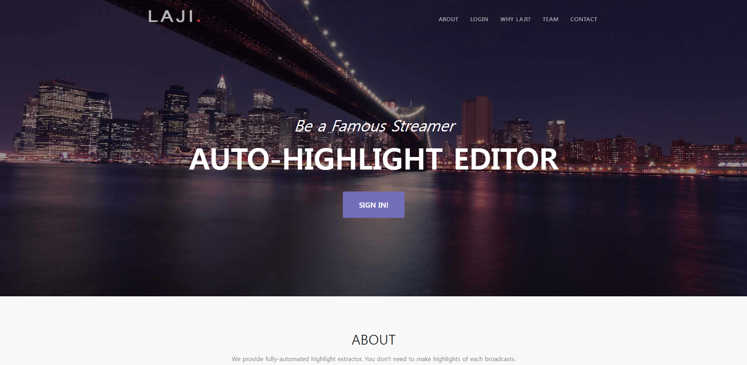

1. **LOGIN**

If you have not signed in or signed up, you will see the following login screen when you access the homepage. The first time you sign in to our page, you automatically become a member of us.

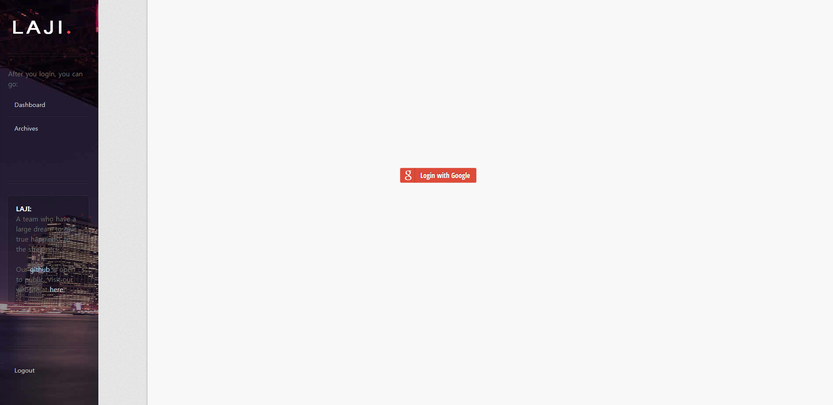

You can sign in by clicking the 'Login with Google' button. If you are a first time to our service, you may see a Google authorization request page. Once you have permission, you will be taken to the homepage for members.

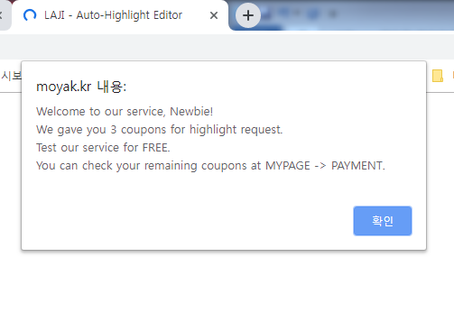

For the newbies, we give 3 coupons that need for requesting highlight.

1. **REQUESTING HIGHLIGHT**

DASHBOARD **–** UPLOAD

You can see the page after sign in, wanting you to enter a URL for the video you broadcasted. Please check your name on the first line.

After that, please enter the full URL and push the button for the next page. Please make sure that your url is correct.

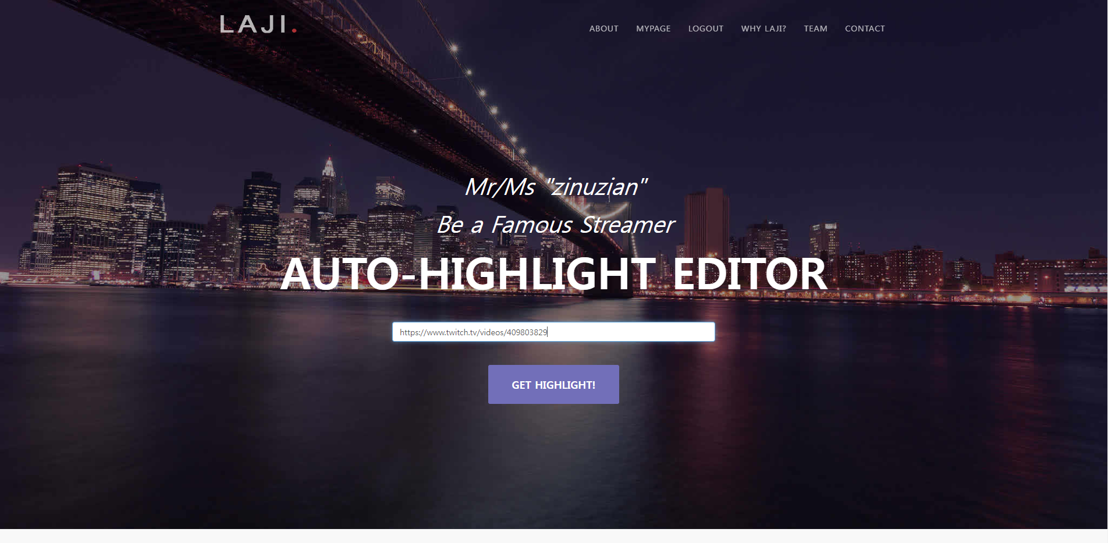

REQUESTINGHIGHLIGHT **– DASHBOARD –** UPLOAD

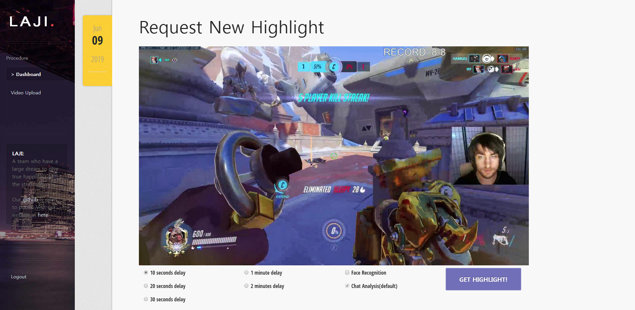

In this page, you can choose the options for making highlights of the video. To introduce about the parameters we provide:

1. **Delay** – decides the length of the video, which will be about 3 times of delay.
2. **Face** **Recognition** – use face recognition algorithm to check emotion of the streamer in the screen. Usually gives a better output.

If you choose face recognition option, you should draw rectangle on the popup layer.

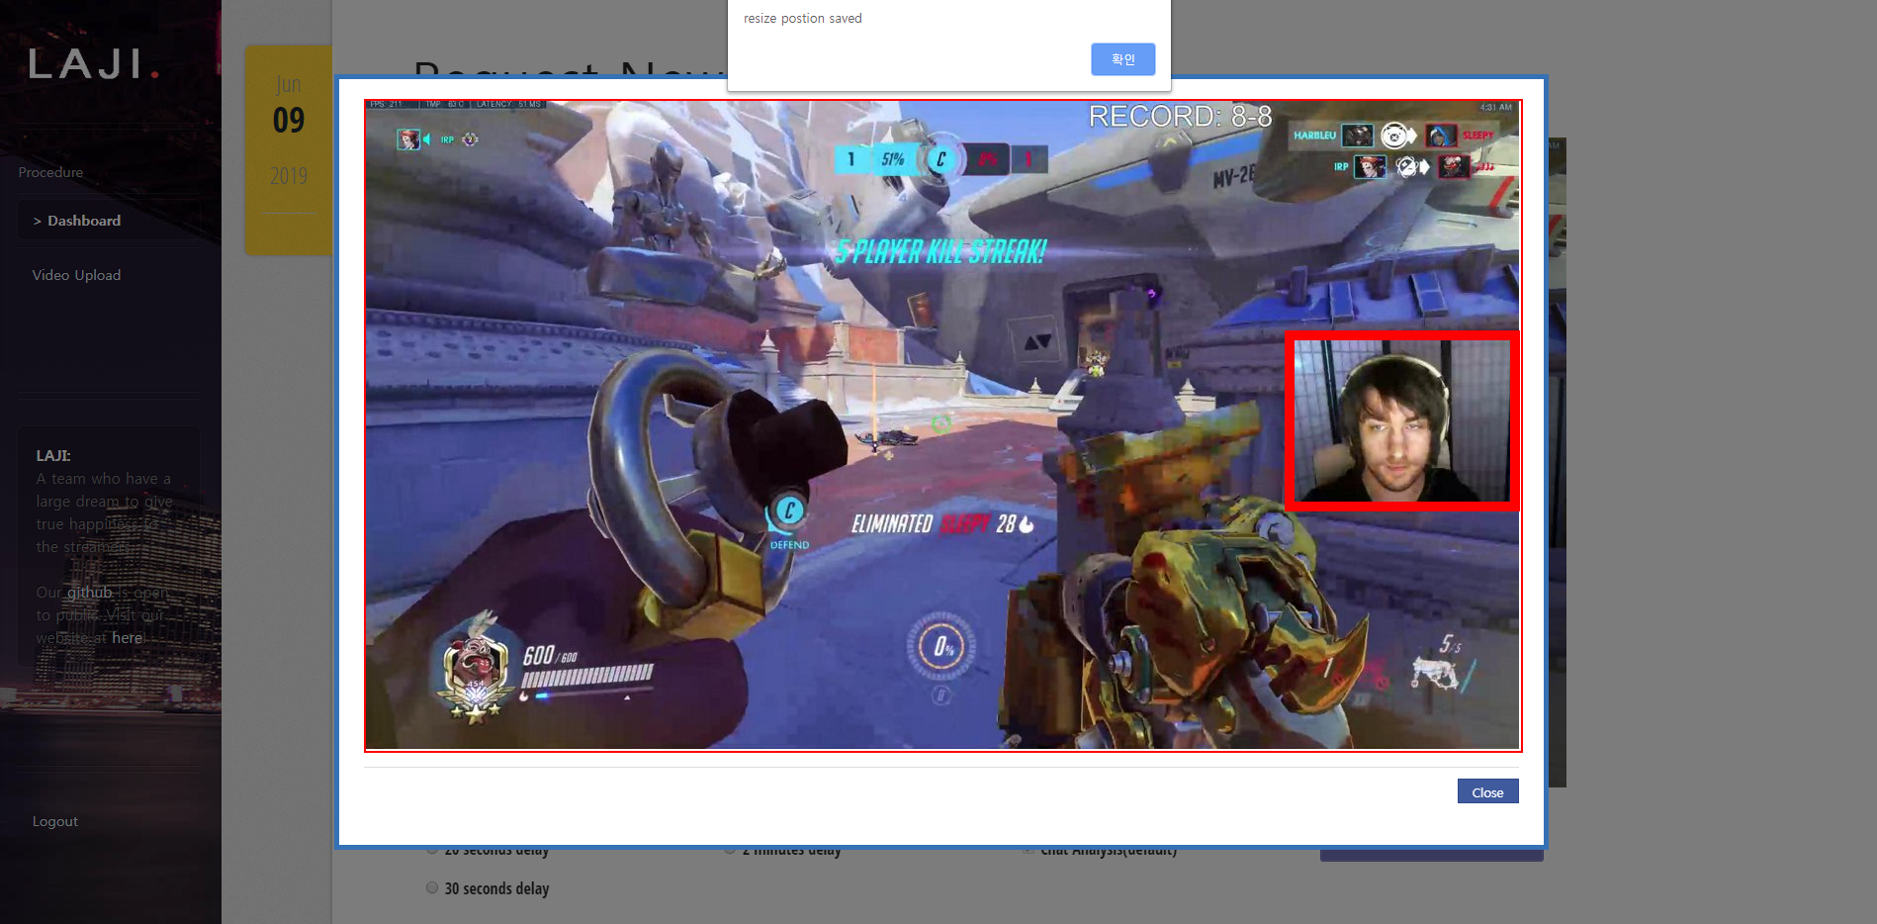

REQUESTINGHIGHLIGHT **–** DASHBOARD **– UPLOAD**

After all, you can check your options, give a title to videos that will be given to you and actually upload the video you downloaded from twitch.

Please be sure that uploaded video **is** the video of the url you given in previous page. The system will send you a failure mail if you input a wrong video.

Finally after the upload is finished, the site will give you a notice and you can still explore the site like making a new request or visiting archive page.

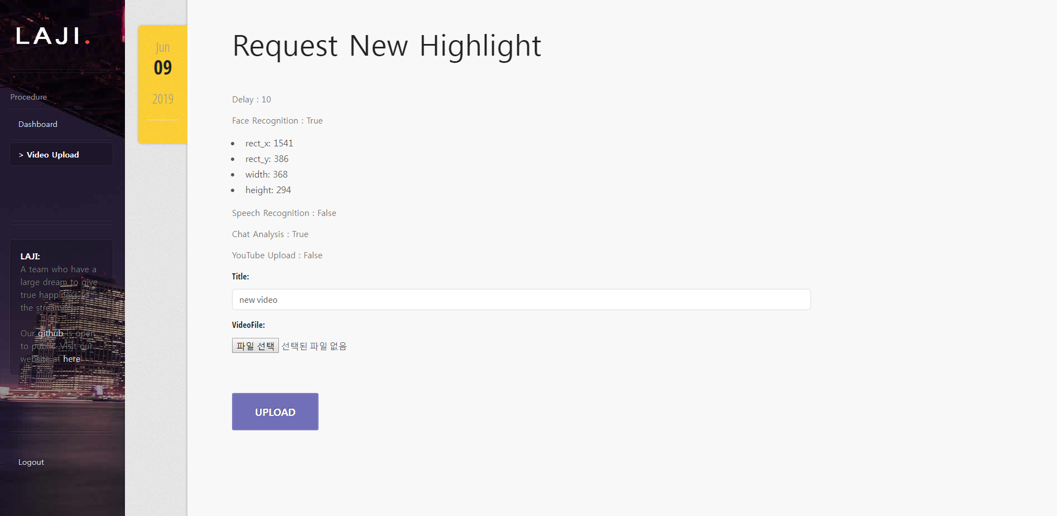

You will receive a completion notification email in your Google account when processing is complete.

However, it may be classified as spam at first, so check your spam folder and release the spam.

1. **ARCHIVE (MYPAGE)**



To see the result of the highlights, you can click the tab ‘MYPAGE’.

In yellow box, you can check the date you requested and title of the video that you input. You can see the video in place just clicking play button.

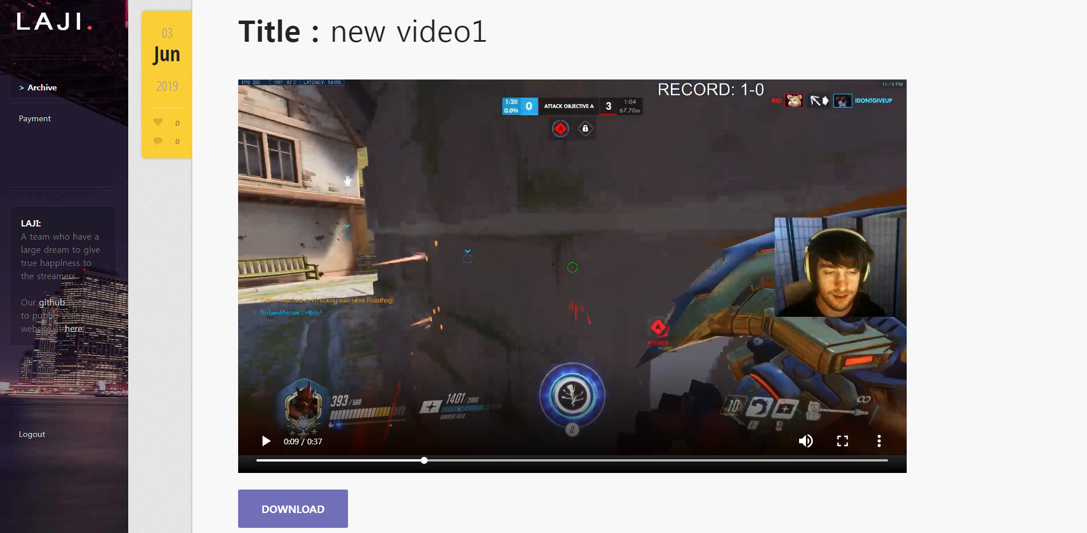

1. **DOWNLOAD HIGHLIGHT**

To download the highlighted video, you just click the button ‘DOWNLOAD’ and download starts immediately. File format is always .mp4 which is same with the video downloaded from twitch.

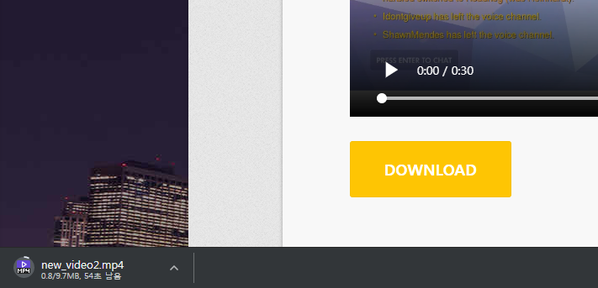

1. **PAYMENT (MYPAGE)**

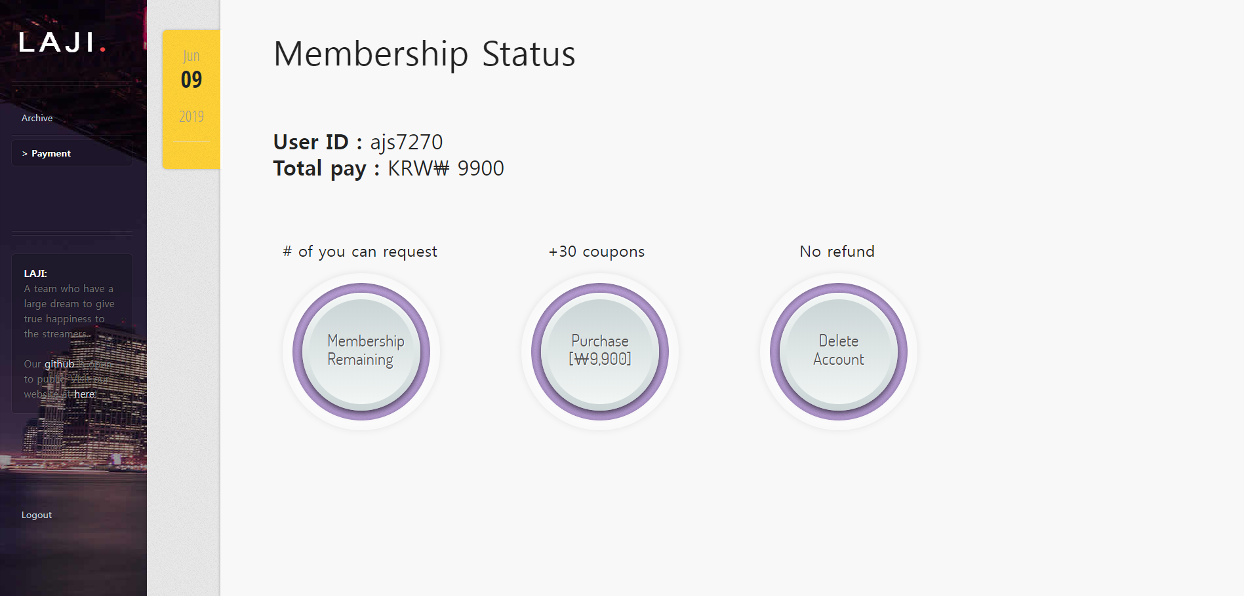

To check your account status, click the ‘Payment’ tab and you’ll see your user ID, total amount of money you purchased. There are three things you can do in this page.

1. 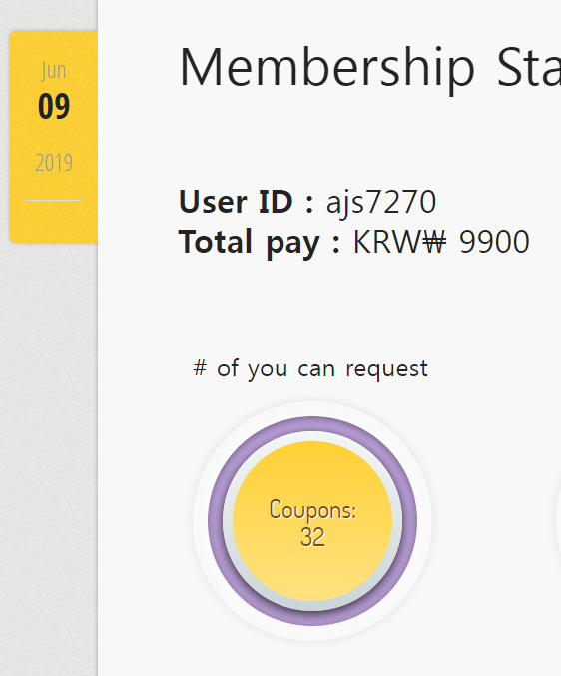**REMAINING COUPONS**

To see the coupons remaining, you just put your mouse over ‘Membership Remaining’.

It turns yellow and gives you information how many coupons left.

1. 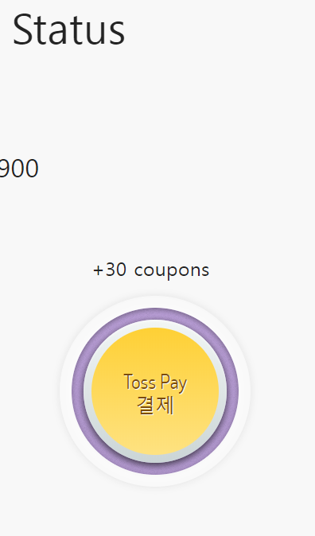**PURCHASE NEW COUPONS**

To purchase coupons, you need to use TOSS.

We give 30 coupons for 9900 KRW. You have to input your phone number and date of birth. After you pay it, we show you the result of payment.

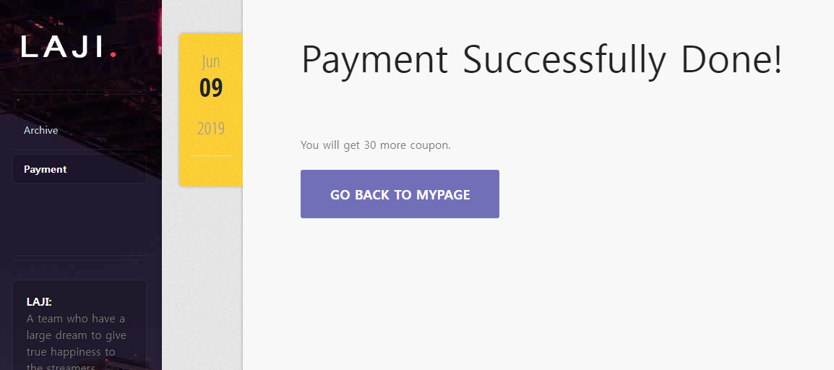 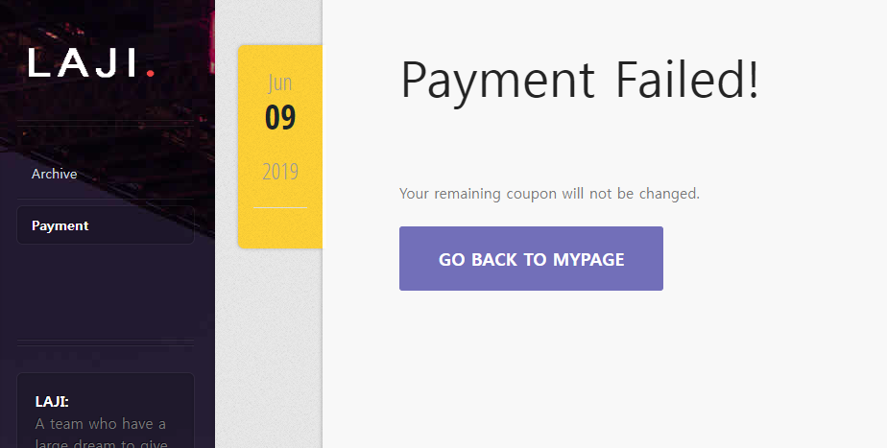

**success fail**

If you have successfully made a payment at Toss, you will be automatically taken to the successful payment page after the payment has been made. If an error occurs, go to the Payment declined page.

1. **WITHDRAW ACCOUNT**

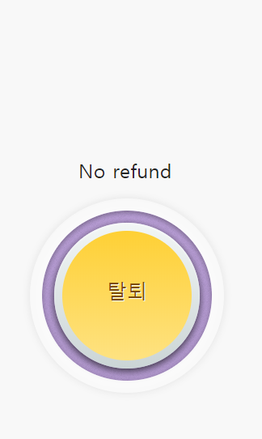If you click the 'Delete Account' button, all information about you will be stored in separated DB. All uploaded files and highlights will be deleted and there’s no way to recover it.

You have to enter your user ID to check if you really want to withdraw your account.

If you enter correctly, withdrawal is complete.

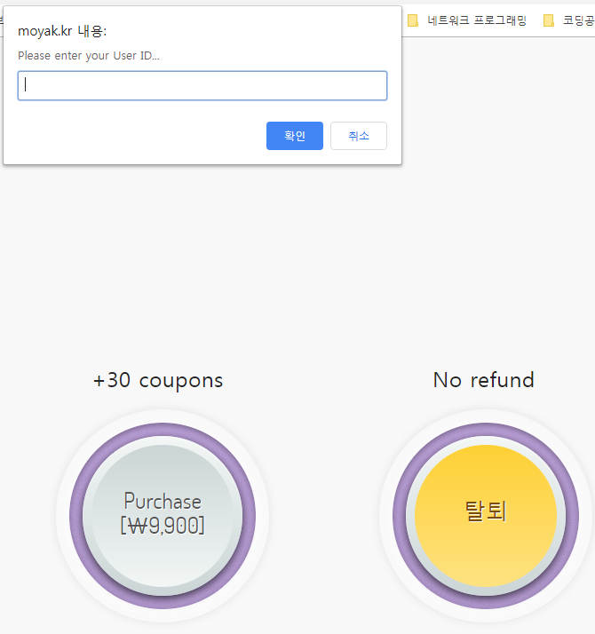

1. **COME BACK**

Whenever you want to come back to our service, you just sign in again and all you private information will be restored with a greeting message below.

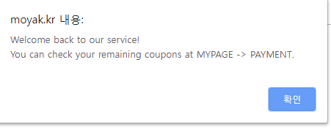

**Greeting message**

**Any question about our service is welcomed. Please contact** [**laji.cau@gmail.com**](mailto:laji.cau@gmail.com)